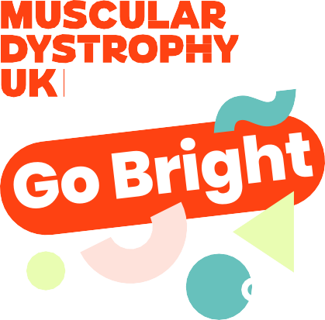

Dear

I’m writing to ask to go big, go bold and Go Bright this March for a charity very close to us. Muscular Dystrophy UK is asking people across the country to Go Bright on 1 March to raise money to help fund groundbreaking research and life-changing support. The ask is simple and fun. We ask that the students of wear one bright thing and each make a small donation. From a sock or headband to t-shirts and full bright outfits, to go as bold as they like this #GoBright.

When you sign up, Muscular Dystrophy UK will be in touch with lots of helpful resources to make your day the brightest it can be. They’ll also put you in touch with your Regional Development Manager, who will be here to help you with all things fundraising.

Over 110,000 young children and adults in the UK live with a muscle wasting condition. Progressive muscle wasting conditions get worse over time and life can be challenging, or cut short. That’s why Muscular Dystrophy UK fund groundbreaking research to understand the different conditions better and to lead us to new treatments; work with the NHS towards universal access to specialist healthcare; share expert advice and support people to live well now; and campaign for people’s rights, better understanding, accessibility, and access to treatments.

“Insert your connection to Muscular Dystrophy UK here if you wish”

You can find out more about Go Bright on Muscular Dystrophy UK’s website: [www.](http://www/) musculardystrophyuk.org/go-bright. If you have any questions, you can send them to events@ musculardystrophuk.org.

We really hope will be able to take part and Go Bright for Muscular Dystrophy UK. It’s a great way to raise awareness as well as funds, and a brilliant chance to brighten up a spring day.

Yours sincerely,