Winchester Inner Wheelchair route

Although the Winchester outer route is possible in a wheelchair, with two or three adjustments, it is quite a challenge and may not be to your taste. As only the most determined wheelchair user would take it on, may I suggest this pleasant sightseeing tour near the centre of the city?

- The tour starts from the car park on Colebrook Street, behind the Guildhall which is in the Broadway. Here you will see the King Alfred statue.
- Leave the car park through the gap in the wall. Now you find yourself on a path where you turn left and can immediately turn right into Abbey Gardens. However, you may choose to continue left up the path towards the Broadway.
- If you go to the Broadway you will pass on your left the ancient sight of Nunnaminster. When you reach the Broadway, turn immediately right and through the main gates into Abbey Gardens. Here you will find the best public toilets and a café/ restaurant, playground and, of course, a delightful garden.
- Now, head for the Broadway again and come out near the King Alfred statue. Now turn right and cross the other end of Colebrook Street, passing the Bishop on the Bridge on your right.
- Turn right before going over the bridge and follow the ramp down beside the river.
- With the city wall on your right and the river on your left continue until you reach College Street and Wolvesey Castle on the right.
- Continue up College Street bearing slightly right, passing the college entrance, the house where Jane Austen died, the college book shop and gift shop, until you turn right and under St. Swithun upon Kingsgate church.
- Now turn right again and into the Cathedral Close.
- Bear left passing The Pilgrim’s School on your right and across the Close to pass through under the passageway to the West front of the Cathedral.
- To return to your car, go back the same way and pass under the arch beside the Cathedral with the Dean Garnier Garden on your right.
- Follow the path through the Water Gate left and pass the pond on the left.
- Cross Colebrook Street into the car park.
- Now, enjoy the rest of the city shops places of interest or maybe just enjoy a spot of lunch.

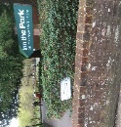
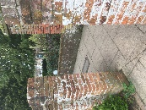
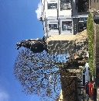
b)
b)
a)

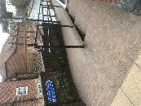
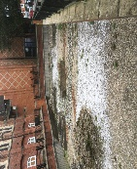
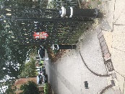
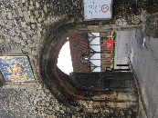
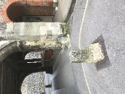
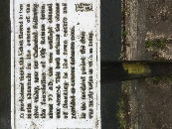
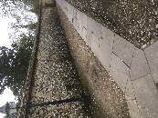
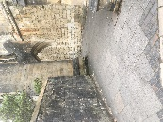
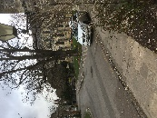
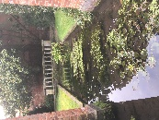
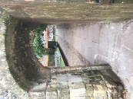
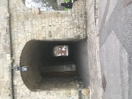
k)
k)
k)
j)
j)
i)
f)
g)
h)
e)
c)
c)

