Introduction

This document provides information and advice about exercise for adults with muscle-wasting conditions, and may be a useful resource for individuals, families, friends and healthcare professionals.

Talk to your doctor or physiotherapist about exercise before you start, especially if you are still undergoing diagnosis or having heart investigations. Exercise caution when selecting the type of strengthening exercise for some muscle-wasting conditions.

This document aims to provide:
- examples of the benefits of exercise and activity
- how to get and stay active
- principles and priorities for safe and effective activity and exercise
- top tips
- links to additional resources and FAQs to support individuals to exercise and live well with their muscle-wasting condition.

1. General health benefits of keeping active and exercising

- Reduces the risk of other diseases (e.g. heart disease and type 2 Diabetes) and promotes a healthy lifestyle.
- Improves heart and lung function to optimise stamina and endurance.
- Makes sure your unaffected muscles are working as well as they can, in other words avoiding weakness not directly caused by the muscle-wasting condition.
- May improve or maintain your ability to perform everyday tasks.
- Reduces avoidable weakness from not using muscles.
- Can reduce fatigue.
- Can improve bone density.
- Can help in controlling your weight.
- Improves your mood/helps you manage stress.
- Can improve your sleep.
- Can help in reducing pain.
- Helps to maintain or improve joint range of movement.

Researchers have not yet identified the optimum amount and type of physical activity/exercise for people with muscle-wasting conditions. It is, however, widely agreed that being inactive is harmful to health and being active in whatever way you can be, is good.

2. How to get and stay active

The type of physical activity and/or exercise most appropriate for you will vary from person to person.

It is important to find something safe to do that you can enjoy, easily achieve and can fit in to your routine. This will depend on your own specific needs, interests and circumstances.

If you haven’t done any regular activity or exercise for a while, start slowly and gradually build up. If you are already active or doing formal exercise, the information here may help ensure you are doing the correct type of exercise in the most beneficial way.

- If you can, try to exercise with peers (even if this is virtually) or tell people what your plans for exercise are, as this helps with keeping you on track.

- Try and work towards a goal, for example:
  - to avoid sitting for more than 30 minutes without moving, or
  - to do some regular exercise/activity three times a week.

- Keep a record of what exercise and activity you do and when, so that you can reflect on gains and improvements.

- Use activity monitors or step counters on your phone, to help keep a track of your activity throughout the day.

.

3. Principles and priorities for safe and effective activity and exercise

This section focuses on three main types of physical activity/exercise:
- aerobic activity or exercise
- strengthening activities or resistance exercise
- stretching exercise.

Aerobic activity/exercise

This type of exercise is any physical activity that makes your heart beat faster and/or increases your rate of breathing. It uses large groups of muscles and, once established, ideally you should be able to sustain it comfortably for a number of minutes.

Examples of aerobic exercise include walking, swimming, using an exercise bike, propelling your wheelchair, doing housework and gardening.

Aerobic activity/exercise improves the function of your heart, circulation and lungs. By improving your general fitness, this type of activity is also good for your overall health and may help prevent chronic disease.

Relatively small increases in physical activity can protect you against chronic disease and can improve your quality of life by allowing you to do a little more each day.

Discuss with your cardiologist, physiotherapist or neurologist what type of aerobic activity may be best for you.

How often should I do aerobic activity/exercise and how long should each exercise session last?

- Make a note of what you can do and for how long.
- Start with what you can do comfortably.
- Gradually increase the length or frequency of sessions. Remember, though, that if you’re having a bad day in terms of fatigue, you may not be able to do much. Don’t give up and feel as though you have taken a backward step. This is entirely normal, and you can restart your activity practice once you’re feeling better.
- Make sure you include rest periods for your muscles to recover and to limit fatigue.
- Try to spread your physical activity/exercise sessions across the week to fit in with your lifestyle and other home/work commitments.

Key messages

- Something is better than nothing.
- Aim not to be still for too long.
- Ensure you pace activity with rest as needed.

How hard should I exercise?

Aim for moderate intensity physical activity.

To exercise at a moderate intensity, you will:

feel warmer and perspire a little

take deeper breaths, but still be able to talk comfortably in full sentences (try repeating this when exercising: this exercise is good for me).

Using the ‘Borg RPE Scale’ (see Appendix 1), you should work up to the RPE Scale levels 3-5 if you can.

Rate how you feel at the beginning of the activity, see what you can do safely and comfortably, and keep this as your starting point from which to work.

Longer and more strenuous activity/exercise sessions should also include a three- to five-minute warm-up to increase your body temperature and reduce the potential for post-exercise stiffness, and a five- to ten-minute cool-down to allow recovery of your heart rate. Your therapist can help you decide how you do this

In summary:

What type of activity? | How often? | How hard? | How long? | What do I need to be careful of?
Aerobic activity/exercise  For example, walking to work, wheeling your wheelchair, activities of daily living, cycling, swimming or static bike  Any activity that uses large muscle groups and that can be maintained continuously and rhythmically for a period of time. | Try to make being active part of your daily routine or try to be active in these ways at least five times a week. | Comfortably out of breath but still able to talk;  Borg RPE Scale 3 to 5. | 30 minutes  intermittent bouts aiming for at least 10 minutes. | Do not exercise to exhaustion  Use the Borg RPE Scale as a guide.

b) Strengthening activities or resistance exercise

Can include working against the force of gravity, using your own body weight, lifting small weights or pulling elastic exercise bands.

Generally, strengthening activities/exercises involve the major muscle groups.

It is important to think about strengthening the muscles of your arms and legs, stomach and back (‘core’) muscles.
- Improved core strength can help improve your posture and balance, which can reduce the risk of falling and can help with day-to-day activities, such as wheelchair transfers.
- Avoid excessive ‘eccentric’ activity. This means repetitive tasks or exercises where the muscle is being lengthened, for example squats.
- Eccentric exercises put much greater force through the muscle and can lead to muscle soreness and potentially some damage.

Talk to your physiotherapist about which muscles you should strengthen and how, as this will be different for everyone.

It is important to think about improving the endurance of your muscles, rather than strengthening or trying to build up muscle bulk. This will help you with day-to-day tasks and allow you to do them for longer, for example, being able to climb more stairs before you get tired. It may not be possible to strengthen muscles that are very weak because of a muscle-wasting condition, but it’s important to maintain what you have for as long as you can.

How often should I do strengthening exercises and how long should each exercise session last?

Ideally you should do strengthening exercises at least twice a week (UK Chief Medical Officer’s Physical Activity Guidelines 2019)

It is better not to do strengthening exercises on consecutive days; give your muscles a chance to recover.

Within an exercise session, you should alternate the muscles you exercise, so if you start with an arm exercise, do a leg exercise next.

If adding these exercises makes your muscles too weak, sore or fatigued to perform daily tasks, then do less exercise or speak to your physiotherapist.

How hard should the strengthening exercises be?

Low- to moderate-strength (resistance) exercises are safe for most people with muscle-wasting conditions.

Avoid lifting heavy weights as this may cause damage to already vulnerable muscles, and put additional strain on surrounding ligaments and joints.

Take care to protect your neck, back and posture when doing any lifting, to avoid other injuries.

Increase the number of repetitions rather than the weight you lift.

Stop the exercise if your muscles shake too much or the movements become jerky.

When you start a new strength exercise you might expect to be a little bit achy, but any muscle soreness should have gone after 48 hours.

In very rare circumstances, people with muscle-wasting conditions can experience changes in the colour of their urine after exercise (in other words, urine that appears the colour of black tea or cola). Attend A&E if you notice such a change, as this could be a condition called myoglobinuria.

In summary:

What type of activity/ exercise? | How often? | How hard? | How much? | What do I need to be careful of?
Strengthening activities/exercises  Using exercise bands, small weights or Tai Chi/Pilates/yoga/mat work style exercises.  Individual programme: seek advice about which muscles to strengthen. | At least twice a week. | Stop before fatigue. | One set of eight to twelve repetitions for each muscle group identified.  Gradually increase to three sets as you are able. | Low/moderate weights; increase number of repetitions rather than weight.

c) Stretching exercises

It is important to have good muscle length and range of movement for day-to-day activities. For example, having enough range in your shoulder joint will help for washing and dressing activities.

You can include stretching exercises in your activity/exercise programme. It is easier and safer to do your stretches when your muscles and joints are warm. Good times to do stretches would be once you have been active or after a bath or shower.

A number of very rare neuromuscular conditions involve tightness/contractures of the spine or other joints. In this case, the goal of these activities would be to keep the flexibility you have, rather than gain more.

Please take care that you do not over-stretch weak muscles or joints that are already very mobile.

If any particular muscles or joints are stiff, you may need a more focused stretching programme. Speak to your physiotherapist, who can advise you which muscles or joints it would be good for you to stretch.

- Activities such as gentle yoga and Pilates can be effective. These exercises and any stretches can be adapted so you do them in the best position for you.

(Please see link in Appendix 1.)

If you are too weak to do your own stretches, you can do them with help from a family member or your carer. (Please see link in Appendix 1.)

How often should I do stretches and how long should each session last?

- Stretches are more effective when you do them regularly.

- Include them in your daily tasks, such as doing stretches for your calf muscles while brushing your teeth.

- Try to hold each stretch for 30-40 seconds.

- The stretch should be slow and sustained, with no bouncing.

In summary:

What type of activity/ exercise? | How often? | How hard? | How long? | What do I need to be careful of?
Flexibility  For example, stretches (lying, seated or standing), Pilates or yoga.  Static or passive stretch. | Try to do this as part of your daily routine or at least two/three times a week. | Stretching sensation but no pain.* | 30- to 40-second holds.  Repeat two to four times  Do not ‘bounce’. | If you have impaired or absent feeling or no appreciation of pain.

*Take extra care with any of the above if you have altered sensation, very weak muscles or poor balance.

4. Top tips

Getting started
- Choose an exercise or activity that you enjoy.
- Choose something safe, and achievable that you can fit into your day-to-day life. For example, if you have problems with your balance, it may be better to use a static exercise bike from which you can easily get on and off.
- Remember activities like housework or walking to work are also all good exercise.
- Start slowly with any new exercise or physical activity; know your limits.
- Do short sessions and build up gradually.

Planning your activity/ exercise
- Include a warm-up and cool-down before exercising.
- ‘Mix and match’ your exercises to let your muscles recover and have periods of rest. For example, if you have done a lot of walking (aerobic exercise using your legs), you may want your next exercise session to be strengthening exercises focusing on your arm and core muscles.

Intensity of exercise
- With aerobic exercise (for example, walking), you should feel comfortably out of breath but still be able to talk, and the exercise should make you perspire a little.
- With new strengthening exercises, you are likely to feel a little bit achy but muscle soreness should have gone within 48 hours.

Precautions
- Do not exercise to exhaustion. Stop and rest when you need to.
- ‘Pace’ your activities and take into consideration what other things you may be doing for the rest of the day/week – little and often is the key.
- You should not experience increased tiredness/fatigue that limits what you can do the next day.
- Avoid excessive ‘eccentric’ activity. This means avoiding repetitive tasks or exercises where the muscle is being lengthened, for example squats.
- Muscle ‘tiredness’ can be confused with muscle ‘weakness’, but tiredness should improve after you have rested. Remember, when you are tired your balance is not as good, so take care not to fall.
- Exercises should not be painful.
- Remember to protect your joints when you exercise by making sure you’re in the correct position/posture.
- In very rare circumstances, people with muscle-wasting conditions can experience changes in the colour of their urine after exercise (in other words, urine that appears the colour of black tea or cola). Attend A&E if you notice such a change, as this could be a condition called myoglobinuria.

5. Links to additional resources and FAQs

FAQs

Where should I exercise?

It is a personal choice and it is important to choose an environment or setting that is well lit, safe and accessible to you.

How can I progress?

Progress and build up your activity levels gradually, particularly if you are currently not very active. It is important that you do this safely; your physiotherapist or other professionals involved in your care (fitness or gym instructor) can advise you on this.

Remember that maintaining your current level of physical ability is a good outcome; it’s not necessary to see big changes from your new physical activity/ exercise to know that it’s working.

How do I keep motivated?

Do something you enjoy; ideally with friends or family to keep up your motivation (and theirs too!).

It is also helpful to have your favourite music at hand, as this can keep you motivated.

Some people find keeping an activity diary useful. Others find a phone activity app (which tracks how many steps you take) help to keep up motivation and enjoyment.

Can exercise do me harm?

Exercise has many benefits and very rarely does any harm. Talk to your physiotherapist or medical team before you start exercising to reduce this risk.

Appendix 1

Borg Rate of Perceived Exertion (RPE) Scale:
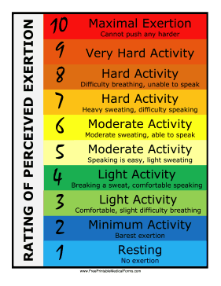

Aerobic exercise:
If you are able to walk as an exercise, consider using the Active 10 app:

https://campaignresources.phe.gov.uk/resources/campaigns/60-one-you-active-10/Overview

If you aim to do 10-minute blocks of physical activity or exercise, that is a positive start.
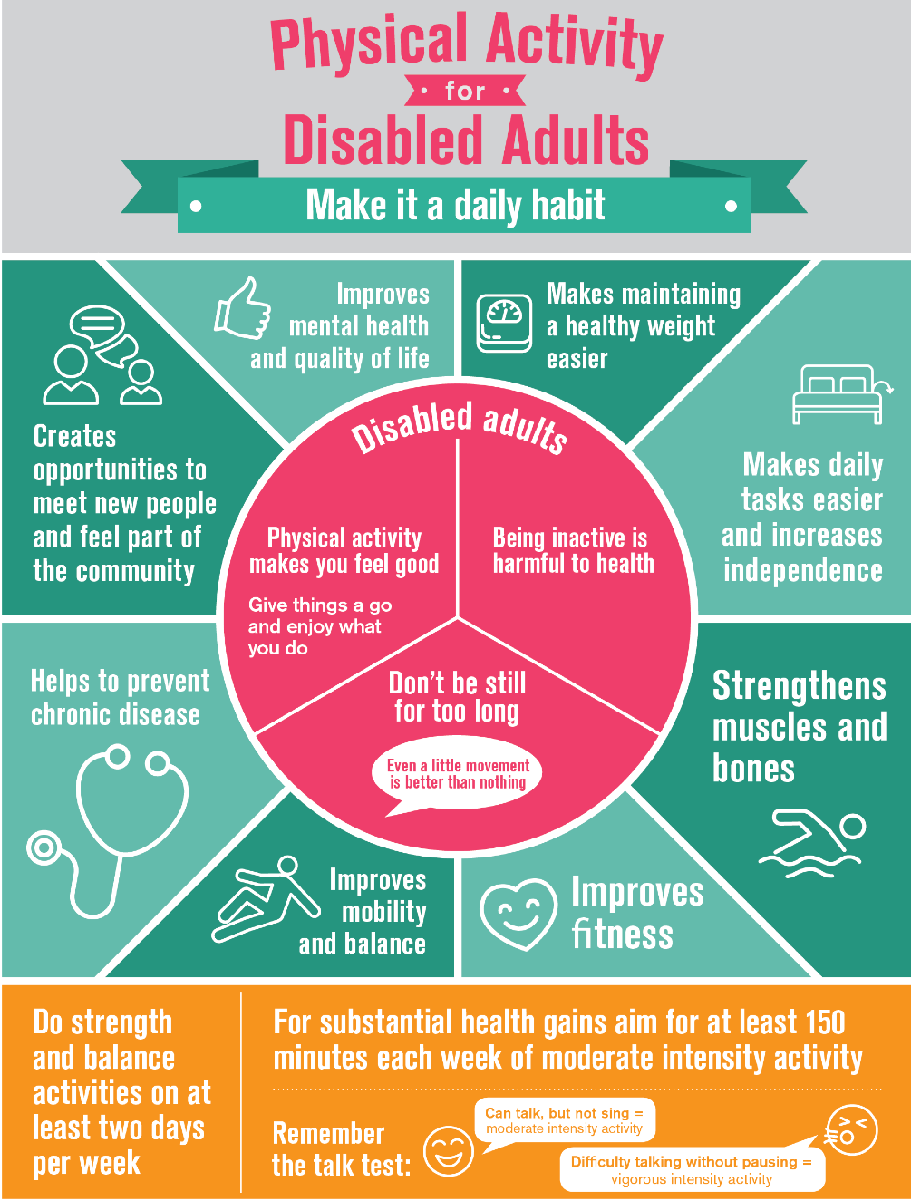

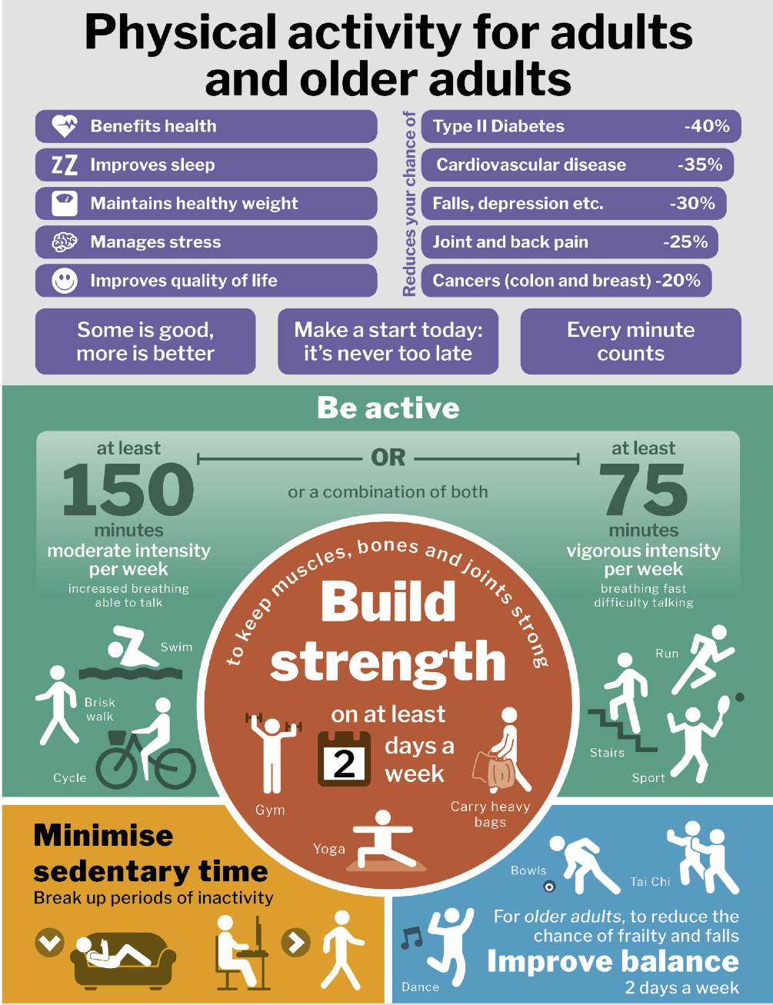

Useful contacts and websites

Pilates:
Pilates is a form of exercise that can be beneficial. Please see below link for Pilates videos neuromuscular therapists/Pilates instructors have created specifically for people with muscle-wasting conditions.

https://youtube.com/playlist?list=PLazCbfp_tqxyve043vSch45aPfMzFfHxX

Scottish Muscle Network information on activity and stretching:

https://www.smn.scot.nhs.uk/wp-content/uploads/2019/01/Stretches-Activity.pdf

Videos on how to exercise safely at home:

https://m.facebook.com/musculardystrophyUK/videos/seated-physio-session-with-marina-di-marco/2726163290999574/

https://m.facebook.com/musculardystrophyUK/videos/standing-physio-session-with-marina-di-marco/340749177339046/

GP Exercise Referral Programme – www.gpexercisereferral.ie

English Federation of Disability Sport – www.efds.co.uk

Sportabilty – www.sportability.org.uk

Parasport – www.parasport.org.uk

Sport England – www.sportengland.org/our-work/disability

Sport Wales – www.disabilitysportwales.com

Scottish Disability Sport – www.scottishdisabilitysport.com

Disability Sports Northern Ireland – www.dsni.co.uk

The NeuroMuscular Centre – www.nmcentre.com

NMC Midlands – nmc-midlands.co.uk

Inclusive fitness initiative – www.activityalliance.org.uk

Condition-specific sites for more information and recommendations for exercise or activity:

CMT UK – www.cmt.org.uk

Muscular Dystrophy Association (USA) – www.mda.org

AGSD-UK – www.agsd.org.uk
FSH Society (USA) – www.fshsociety.org

Key contributors:

Name | Job title | Place of work
Jo Reffin  Sarah Holmes  Sherryl Chatfield  Suni Narayan | Clinical lead physiotherapist in neuromuscular conditions  Clinical specialist physiotherapist in neuromuscular conditions  Clinical specialist physiotherapist in neuromuscular conditions  Clinical specialist physiotherapist in neuromuscular conditions & care coordinator | King’s College Hospital, London  National Hospital for Neurology and Neurosurgery, London  St George’s Hospital, London  University Hospitals Southampton NHS Foundation Trust

Disclaimer

While every reasonable effort is made to ensure that the information in this document is complete, correct and up-to-date, this cannot be guaranteed and Muscular Dystrophy UK shall not be liable whatsoever for any damages incurred as a result of its use. Muscular Dystrophy UK does not necessarily endorse the services provided by the organisations listed in our factsheets.

Here for you
The friendly staff in the care and support team at the Muscular Dystrophy UK’s London office are available on 0800 652 6352 or info@musculardystrophyuk.org from 8.30am to 6pm Monday to Friday to offer free information and emotional support.

If they can’t help you, they are more than happy to signpost you to specialist services close to you, or to other people who can help.

www.musculardystrophyuk.org

