MD (Muscular Dystrophy) 11 mile Winchester Walk
Winchester predates London as the capital of England. It is a beautiful town where you can absorb the ancient history of England. The Queen and Prince Philip came here soon after the Queen’s Coronation in l953.
This 11 mile walking route uses footpaths and roads just around the edge of Winchester where it meets the countryside and the centre of Winchester is never more than 1.5 miles away. The route can be started from various points, and throughout, these are indicated in bold. It can be completed in its entirety or it can be split into smaller sections by using either bus or footpath links back to the town centre.
The start shown here, north-east of Winchester, is from a car park on Hillier Way. (Turn off Worthy Road to Russell Road and continue down to the river and Hillier Way.)

- START From Hillier Way car park. Follow the path through Hilliers Haven until the river is reached. Bear right and left over the river and go through the gap in the wall, into playing fields. Turn right immediately and follow the path parallel to the river.

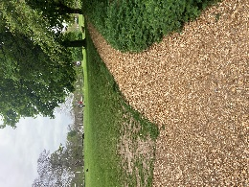
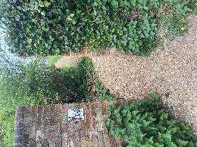
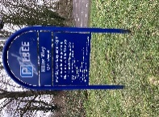
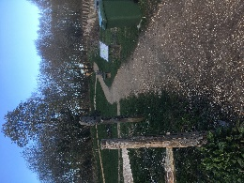

- When it bends to the left, continue over the grass and under the trees. Then turn left into Grosvenor Drive (Abbots Barton) right into Cavendish Grove and a path to Frances Gardens.
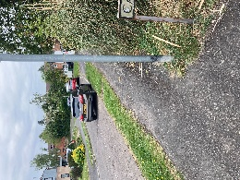
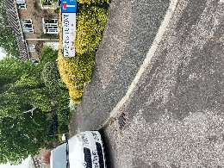
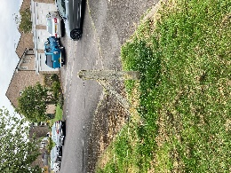
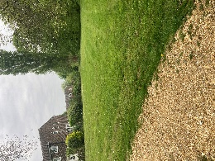

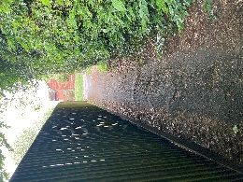
- Turn right along Francis Gardens which becomes a footpath to Worthy Road.
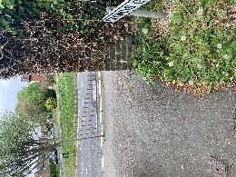

- Cross Worthy Road and turn right along path to Colley Close.
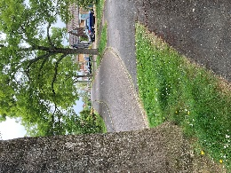
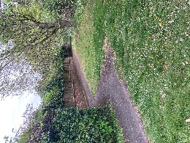

- At the end of Colley Close follow a path which leads to Courtenay Rd. Bear right to where it opens into the fields. Follow path/cycleway turning left and under railway bridge.
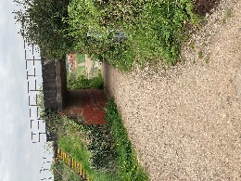
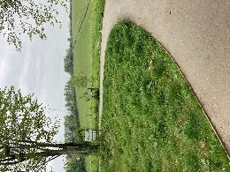
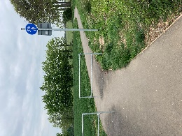
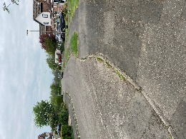
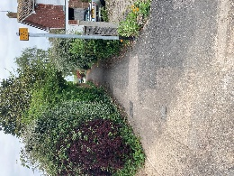

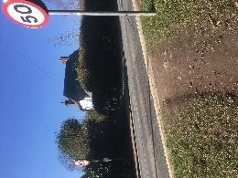
- The path/cycleway takes you straight ahead gradually bending right to follow the fence to a T junction with paths from the line of trees. Turn left and go past the school until you reach B3420, Andover Road (bus route) where route crosses by the 50 sign.

- Continue westwards along footpath through Harestock estate and across Harestock Road.
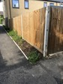
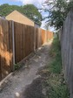
- Where the path changes to newer topping, turn right between fences and then, after a few metres, left by green bin and garage wall. Continue along this path past Primary School grounds to the top of Bradley Road. Cross Bradley Road and continue along the path for about ¼mile, until it meets the B3049 Stockbridge Road (bus route).

- Cross into Salters Lane then continue into Lanham Lane. (There are boundary and field paths on the right, which may be used in preference to the carriageway.) After about a mile turn left when electricity pylons are in view and join the Clarendon Way. Pass Royal Winchester Golf Course to Sarum Road.
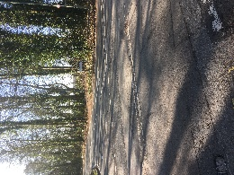
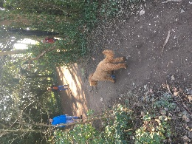
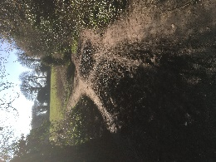
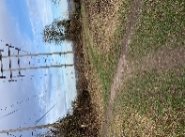

- Turn right on Sarum Road and continue until a permissive path turns off left through the trees and into fields.
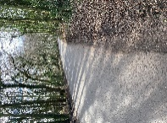
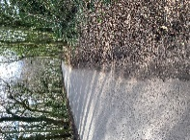
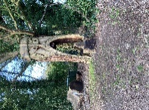
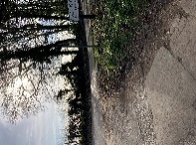

- Pass the Permissive Path sign and continue until path bears right and down to Romsey Road at Pitt. Cross the road at bus stop and take path behind bus stop upwards towards the golf course.
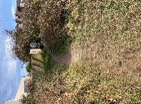
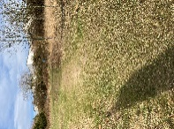
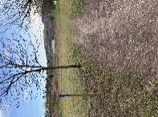
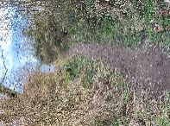
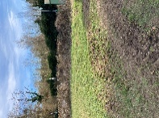
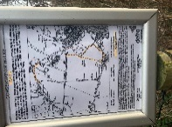

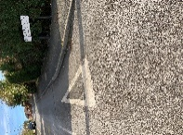
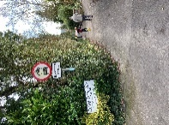
- Continue on designated pathway across South Winchester Golf Course (Take care) towards Oliver’s Battery and out into Treble Close. Follow path into Momford Rd then left and right into South View Rd. At the end, turn right down Compton Way, which becomes a path, to reach the playing field car park.

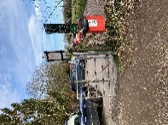
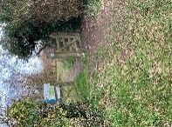
- Turn left through car park and follow footpath round the field to leave by a gate and through the trees to a second gate.

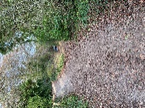
- Turn left and continue up past pylon. Bear left then after 200 metres where path descends to roadway keep left to get to footbridge over A3090, Badger Farm Road.
- Here it joins the Clarendon Way again (Winchester Cathedral to Salisbury Cathedral).

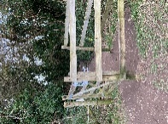
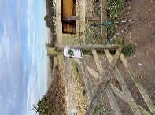
- Go over the bridge. Turn right then keep left for a short distance and through gate into open fields. Lovely view of Winchester from here. Continue descent along the breast the field ridge. After 600 metres turn right through gate and left down the path in the hollow way as far as a footbridge over the railway.
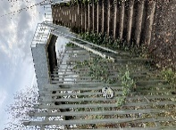
- Cross the bridge and turn right and down Mead Road to the B3335, St Cross Road (bus route).

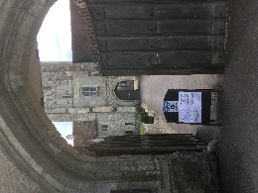
- Cross the road with care and turn right to reach The Bell Inn (Light controlled crossing to the left.) and turn left to the entrance to St Cross Hospital where the Wayfarer’s Dole may be collected.

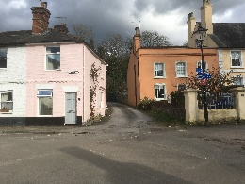
- Through gate into the Water Meadows and turn left on the path north towards Winchester, along the River Itchen.
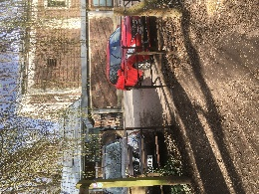
- Right and left across Garnier Road and continue beside the river, with the college sports fields to the left. At the gate turn right (The College, New Hall is opposite the gate.) and keep to the right until the road crosses the river and turns left into Wharf Hill.

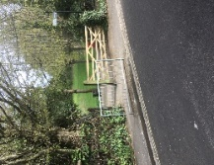
- Follow Wharf Hill up past the Black Boy and cross Chesil Street / Bar End Road into East Hill. Keep left on Quarry Road and within 100 meters turn left and through a gate onto St Giles’s Hill. Turn right up the steps to the top and turn left to reach the city view point. (Amazing view of Cathedral, Guildhall etc.).

- Continue alongside the fence to the highest point on the path, then walk up across the green and east along Northbrook Avenue or Stratton Road to re-join Quarry Road.
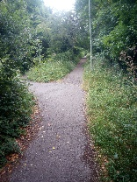
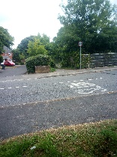
- Go left along Quarry Road until it meets the B3404 Alresford Road. The Golden Lion is 100 metres on the left here.
- Cross the B3404, turn right, then before the road goes over the M3, turn left to follow a tree-lined footpath beside the M3 cutting.

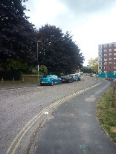
- Keep straight ahead for 600 metres then turn sharp left along a paved path and roadway leading between tall blocks of flats and into Winnall Manor Road.
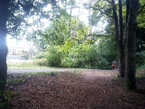
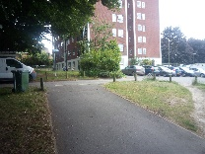

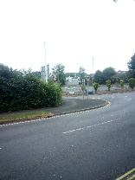
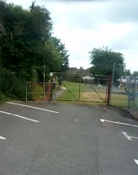
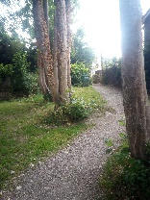
- Turn right and then left into Winnall Valley Road and down at the end, enter a Children’s playground. Follow path up left through the playground, through the gate and turn right into Ebden Road.

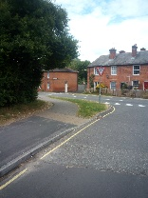
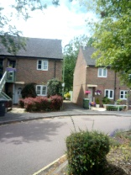
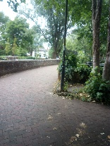
- After a short distance cross Easton Lane / Wales Street, left and right into Colson Rd and take path between houses to the River Itchen. Turn left and follow the path until it reaches Wales Street again then turn right to the entrance to Winnall Moors.

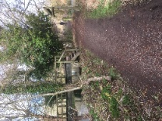
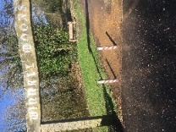
- Follow the path through Winnall Moors keeping left as far as a footbridge over the river and right between two streams Then left across another bridge over the river and through a gate into River Park recreation fields.
- Continue west, diagonally across recreation field and onto park path by railings and over the river. Follow the path alongside a line of trees and through a traffic barrier as it bears right.
- Here keep right along the access road to the Rugby Club. Follow the road round a left bend to the car park at Hilliers Haven.

