Lay Research Panel -
Application form
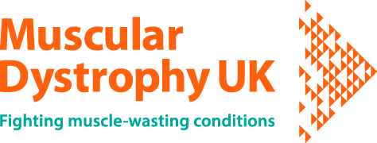
The information on this form will be used by Muscular Dystrophy UK and its Lay Research Panel to ensure we keep a balanced membership of the Panel, in terms of condition of interest, expertise, geographic location and demographic. We will also use the information to contact you about your application. Your details will be securely stored on our database; you can read our Privacy Policy at: https://www.musculardystrophyuk.org/privacy-cookies/.
Name of Applicant:
Address (county is sufficient):
Email address:
Telephone:
Date of birth:
Do you have any potential conflicts of interest? For example, involvement with charitable or commercial organisations.
If yes please give details of your role.

Experience
Please tell us about your personal connection to, or experience of, muscle wasting conditions.
Please refer to the job description for new Lay Research Panel members which will help you to complete this section
Personal Statement
Please provide a short statement about yourself and why you are interested in joining the Lay Research Panel. This will help us to assess your suitability to become a member of the Panel.
Please refer to the job description for new Lay Research Panel members which will help you to complete this section

As part of the application process we would like to circulate the Experience and Personal Statement sections of this form to the current members of the Muscular Dystrophy UK Lay Research Panel. Please sign below to indicate your permission for us to do so.

Signature of Applicant:

Name (printed):

Date:

Please print this document and sign it before scanning and sending an electronic copy to the Research Officer, John Copier at Researchgrants@musculardystrophyuk.org. Alternatively, you can send the signed, hard copy to:

Research Officer
Muscular Dystrophy UK
61A Great Suffolk Street
London
SE1 0BU

The deadline for applications is 27 October 2022

If you have any questions please contact the research team at research@musculardystrophyuk.org.

